جامعة بني سويف |  | كلية الطب البيطري
الأبحاث الطلابية
للعام الجامعي 2019/2020 الفصل الدراسي الثاني
الفرقة الدراسية: الرابعة قديم
اسم المقرر:
كود المقرر:
اسم القسم:
الرقم القومى:
عنوان البحث :

Title Title Title Title Title Title Title Title Title Title Title Title Title Title Title Title
ABSTRACT: (200-250 words)
Write the abstract here Write the abstract here Write the abstract here Write the abstract here Write the abstract here Write the abstract here Write the abstract here Write the abstract here Write the abstract here Write the abstract here Write the abstract here Write the abstract here Write the abstract here Write the abstract here Write the abstract here Write the abstract here Write the abstract here Write the abstract here Write the abstract here Write the abstract here Write the abstract here Write the abstract here Write the abstract here Write the abstract here Write the abstract here Write the abstract here Write the abstract here Write the abstract here Write the abstract here Write the abstract here Write the abstract here Write the abstract here Write the abstract here Write the abstract here Write the abstract here Write the abstract here.

INTRODUCTION
Write the introduction here Write the introduction here Write the introduction here Write the introduction here Write the introduction here Write the introduction here Write the introduction here Write the introduction here Write the introduction here Write the introduction here Write the introduction here Write the introduction here Write the introduction here.

Body
SUBTITLE: write the subtitles of your article`s body here
Write text here Write text here Write text here Write text here Write text here Write text here Write text here Write text here Write text here Write text here Write text here Write text here Write text here Write text here Write text here.
SUBTITLE:
Write text here Write text here Write text here Write text here Write text here Write text here Write text here Write text here Write text here Write text here Write text here Write text here Write text here Write text here Write text here.
SUBTITLE:
Write text here Write text here Write text here Write text here Write text here Write text here Write text here Write text here Write text here Write text here Write text here Write text here Write text here Write text here Write text here Write text here Write text here Write text here Write text here Write text here Write text here Write text here Write text here Write text here Write text here Write text here Write text here Write text here Write text here Write text here.
SUBTITLE:
Write text here Write text here Write text here Write text here Write text here Write text here Write text here Write text here.
Write text here Write text here Write text here Write text here Write text here Write text here Write text here.
ADD SUBTITLES AS YOU NEED
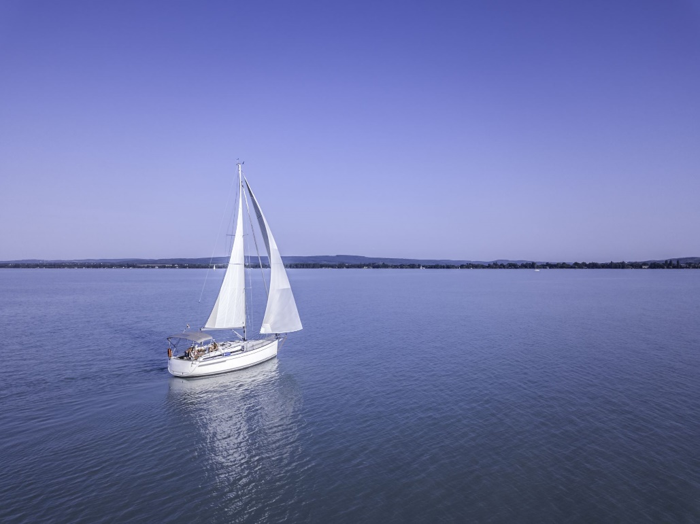
Figure 1. Add figures when possible. Write the title of figures and illustrations below them. Order figures by numbering.

CONCLUSIONS: (100-150 words)
- Write text here Write text here Write text here Write text here.
- Write text here Write text here Write text here Write text here.
- Write text here Write text here Write text here Write text here.
- Write text here Write text here Write text here Write text here.

REFERENCES
Provide details of each source (citation) you used in the introduction or body. Order your references alphabetically.
e.g.
Hassan, A. H. A., Bergua, J. F., Morales-Narváez, E., & Mekoçi, A. (2019). Validity of a single antibody-based lateral flow immunoassay depending on graphene oxide for highly sensitive determination of E. coli O157: H7 in minced beef and river water. Food chemistry, 297, 124965.
Hassan, A. H. A., Bergua, J. F., Morales-Narváez, E., & Mekoçi, A. (2019). Validity of a single antibody-based lateral flow immunoassay depending on graphene oxide for highly sensitive determination of E. coli O157: H7 in minced beef and river water. Food chemistry, 297, 124965.
Hassan, A. H. A., Bergua, J. F., Morales-Narváez, E., & Mekoçi, A. (2019). Validity of a single antibody-based lateral flow immunoassay depending on graphene oxide for highly sensitive determination of E. coli O157: H7 in minced beef and river water. Food chemistry, 297, 124965.

